

**DATABASE**

**SPECIFICATIONS**

*Next-Gen Restaurant Application Database System (NRADS)*

*Nicholas Forleo: nvf5178@psu.edu*

**School of Graduate Professional Studies**

Information Science Department

INSC 521 - Introduction to Database Concepts

Mar. 2024

# Document Control

## Work carried out by:

|  |  |  |
| --- | --- | --- |
| **Name** | **Email Address** | **Other** |
| **Nicholas Forleo** | **nvf5178@psu.edu** |  |
|  |  |  |
|  |  |  |

## Revision Sheet

Changes in **Bold** are new since the last submission.

|  |  |  |
| --- | --- | --- |
| **Release No.** | **Date** | **Revision Description** |
| 1.0 | 01/21/2024 | Milestone 1 Creation |
| 1.1 | 01/26/2024 | - Added username and password to Requirement No. 9  - Changed “shall” to “will”  - Added Purpose and Outcome section to Milestone 1  - Modified DR regarding logs to note location of stored logs  - Separated menu and tab into respective DR  - Modified attributes for all Core Requirements to be more specific and their referenced page numbers |
| 2.0 | 01/29/2024 | - Milestone 2 Creation |
| 2.1 | 02/07/2024 | - Updated diagram to show Staff is-a User relationship  - Deleted and re-inserted diagram to verify it will persist on download (The web version of MS word was giving me problems, will save via MS Teams and submit as PDF from this version on) |
| 3.0 | 02/13/2024 | - Milestone 3 Creation  - Modified DR1 to remove attribute *table_layout* and replace with directory location where layouts will be saved to  - Modified DR3 to include the last 3 attributes for more accurate data records  - Removed *gratuity* from DR7  - Updated ERD to show Customer pays Transaction relationship |
| 3.1 | 02/25/2024 | - Expanded all many-to-many type relationships in Logical Model (Staff $$→$$ Locations (Works_At), Locations $$→$$ Layouts (Location_Contains_Layout), Layout $$→$$ Tables (Layout_Contains_Table), Tab $$→$$ Menu (Tab_Has_Menu_Item))  - Changed store_id to location_id in Locations table  - Added Legend to Logical diagram  - Added Function Dependency Descriptor for new tables mentioned above  - Modified Month on Title page |
| 4.0 | 02/26/2024 | - Milestone 4 creation  - Added Address table to Logical model and its Functional Dependencies (FD)  - Added quantity attribute to Tab_Has_Menu_Item table in FD and Logical Model |
| **5.0** | **03/29/2024** | **- Milestone 5 creation**  **- Added system generated ERD** |

**DATABASE SPECIFICATIONS**

**TABLE OF CONTENTS**

Document Control i

Work carried out by: i

Revision Sheet i

Milestone 1: Data Requirements 1

System Name or Title 1

Core requirements 1

Milestone 2: Conceptual Design 2

Diagram 2

Assumptions and Constraints 2

Milestone 3: Logical Design 3

Entity Relationship Diagram 3

Assumptions and Constraints 3

Milestone 4: Normalization and 4

Milestone 5: Physical Design 4

Assumptions and Constraints 4

Naming Conventions 4

Tables 4

**Examples of values** 4

**Notes** 4

Milestone 6: SQL queries and 6

# Milestone 1: Data Requirements

## System Name or Title

Next-Gen Restaurant Application Database System (NRADS)

**Purpose**

This section will describe the data requirements needed to facilitate the successful creation of the Next-Gen Restaurant Application (NRA) as defined in the Software Requirements Specification (SRS).

**Outcome**

This section will define the data entities and their attributes needed to support the NRA.

## Core requirements

|  |  |  |  |  |
| --- | --- | --- | --- | --- |
| No. | Requirement | Referenced page in SRS | Referenced Section in SRS | Referenced Paragraph in Section |
| 1 | The system will store general restaurant information including store_id, address, table layout file location (/home/user/layouts/), table_occupancy, table_availability, table_type, table_id, layout_id | 3  5  10  11 | 1.2  2.2  3.5.2  3.5.3 | 1.2.1  2.2.1  2.2.9  all  3.5.3.6 |
| 2 | The system will store customer information including customer_id, phone_number, first_name, last_name, date_of_birth. | 3  5  10  11  13 | 1.2  2.2  3.5.3  3.5.3  5.3 | 1.2.2  2.2.2  3.5.3.2  3.5.3.3  3.5.3.4  5.3.1 |
| 3 | The system will store walk-in and reservation information including reservation_id, customer_id, party_size, wait_time, is_walkin, expected_start_time, and actual_start_time.. | 3  5  5  10  11  12 | 1.2  2.1  2.2  3.5.3  3.5.3  3.5.6 | 1.2.2  3  2.2.2  2.2.7  2.2.9  3.5.3.1  3.5.3.7  3.5.3.8  all |
| 4 | The system will store staff (host/hostess, Servers, Kitchen Staff, Restaurant Management) information including staff_id, date_of_birth, phone_number, address, and availability. | 3  5  5  11 | 1.2  2.1  2.2  3.5.3 | 1.2.3  1.2.7  3  2.2.2  3.5.3.5 |
| 5 | The system will store transaction information including transaction_id, staff_id, customer_id, tab_id, total, tip, datetime, currency, payment_method, and location. | 3  5  5 | 1.2  2.1  2.2 | 1.2.4  3  2.2.4 |
| 6 | The system will store menu information including menu_item_id, menu_item_description, menu_item_name, menu_item_ingredients, minimum_age_to_order, current_inventory, price | 3  5  5  11 | 1.2  2.1  2.2  3.5.4 | 1.2.5  3  2.2.3  2.2.5  2.2.8  all |
| 7 | The system will store tab information including sales_tax, menu_item_id, customer_id, staff_id, tab_total, tab_id, datetime, customer_id, and tab_limit_amount | 5  9 | 2.2  3.5 | 2.2.5  all |
| 8 | The system will store schedule structure information including required_days, time, and required_staff_levels, staff_assignment. | 3  5  5 | 1.2  2.1  2.2 | 1.2.7  3  2.2.6 |
| 9 | The system will handle user authentication including username, password, account_type. | 13 | 5 | 5.1  5.2 |
| 10 | The system will store log information on file system in /var/log/ | 11 | 3.5.5 | all |

# Milestone 2: Conceptual Design

## Diagram

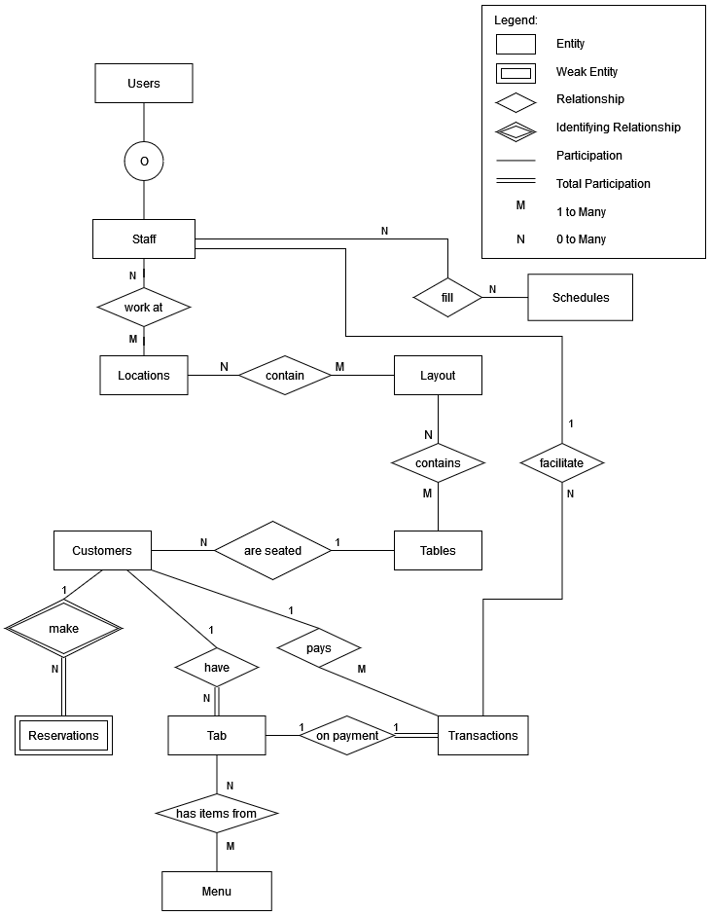

## Assumptions and Constraints

1. Staff ‘is-a’ user.
2. Staff must work at at least one location.
3. A location can have any number of staff assigned to work.
4. A location can contain different layouts.
5. A layout must belong to a location.
6. Staff can fill any number of schedule slots (or none).
7. A schedule can have any number of staff assigned to work.
8. A layout must contain at least one table.
9. A table can belong to any number of layouts.
10. A customer can only be seated at one table.
11. A table can have any number of customers seated at it.
12. A customer can make a reservation but does not have to make a reservation.
13. A reservation must belong to a customer.
14. A tab must belong to a customer.
15. A tab must be compiled of at least one menu item.
16. A menu item can be associated with any number of tabs.
17. A customer can have any number of tabs open.
18. A customer pays to create a transaction.
19. A transaction must close out a tab.
20. A tab can only have one transaction.
21. A staff member must facilitate a transaction.
22. Staff can facilitate any number of transactions.

# Milestone 3: Logical Design

## Functional Dependencies

**Entity name**: Users

**Attributes**:

user_id, name, position, access_level

**Functional dependencies**:

user_id → name, position, access_level

|  |  |  |  |
| --- | --- | --- | --- |
| **Attributes not in FD** | **Attributes on the left** | **Attributes on both sides** | **Attributes on the right side** |
|  | user_id |  | name, postion, access_level |

**Attribute closures**:

user_id+ = user_id, name, position, access_level

**Unique keys**: user_id

**Entity name**: Staff

**Attributes**:

staff_id, user_id, date_of_birth, phone_number, address1, address2, city, state, availability, is_active, location_id

**Functional dependencies**:

staff_id → user_id, date_of_birth, phone_number, address1, address2, city, state, availability, name, is_active, location_id

user_id → staff_id, date_of_birth, phone_number, address1, address2, city, state, availability, name, is_active, location_id

|  |  |  |  |
| --- | --- | --- | --- |
| **Attributes not in FD** | **Attributes on the left** | **Attributes on both sides** | **Attributes on the right side** |
|  |  | staff_id, user_id | date_of_birth, phone_number, address1, address2, city, state, availability, name, is_active, location_id |

**Attribute closures** (if any):

user_id+ = staff_id, user_id, date_of_birth, phone_number, address1, address2, city, state, availability, name, is_active, location_id

staff_id+ = staff_id, user_id, date_of_birth, phone_number, address1, address2, city, state, availability, name, is_active, location_id

**Unique keys**: the key for this table is/are

staff_id*

user_id

Both can be used, but because a user can exist without being staff, we will just use staff_id to be explicit as possible.

**Entity name**: Scheduled

**Attributes**:

schedule_id, staff_id

**Functional dependencies**:

None

|  |  |  |  |
| --- | --- | --- | --- |
| **Attributes not in FD** | **Attributes on the left** | **Attributes on both sides** | **Attributes on the right side** |
| schedule_id, staff_id |  |  |  |

**Attribute closures** (if any):

**Unique keys**: the key for this table is/are

schedule_id, staff_id (super key)

**Entity name**: Works_At

**Attributes**:

staff_id, location_id

**Functional dependencies**:

none

|  |  |  |  |
| --- | --- | --- | --- |
| **Attributes not in FD** | **Attributes on the left** | **Attributes on both sides** | **Attributes on the right side** |
| staff_id, location_id |  |  |  |

**Attribute closures** (if any):

**Unique keys**: the key for this table is/are

staff_id, location_id (super key)

**Entity name**: Locations

**Attributes**:

store_id, address1, address2, city, state, layout_id

**Functional dependencies**:

store_id → address1, address2, city, state, layout_id

|  |  |  |  |
| --- | --- | --- | --- |
| **Attributes not in FD** | **Attributes on the left** | **Attributes on both sides** | **Attributes on the right side** |
|  | store_id |  | address1, address2, city, state, layout_id |

**Attribute closures** (if any):

store_id+ = store_id, address1, address2, city, state, layout_id

**Unique keys**: the key for this table is/are

store_id

**Entity name**: Schedules

**Attributes**:

schedule_id, required_start_time, required_end_time, position, filled_by_staff_id

**Functional dependencies**:

schedule_id → required_start_time, required_end_time, position, filled_by_staff_id

|  |  |  |  |
| --- | --- | --- | --- |
| **Attributes not in FD** | **Attributes on the left** | **Attributes on both sides** | **Attributes on the right side** |
|  | schedule_id |  | required_start_time, required_end_time, position, filled_by_staff_id |

**Attribute closures** (if any):

schedule_id+ = required_start_time, required_end_time, position, filled_by_staff_id

**Unique keys**: the key for this table is/are

schedule_id

**Entity name**: Location_Contains_Layouts

**Attributes**:

location_id, layout_id, active

**Functional dependencies**:

location_id, layout_id → active

|  |  |  |  |
| --- | --- | --- | --- |
| **Attributes not in FD** | **Attributes on the left** | **Attributes on both sides** | **Attributes on the right side** |
|  | location_id, layout_id |  | active |

**Attribute closures** (if any):

location_id, layout_id+ = active

**Unique keys**: the key for this table is/are

location_id, layout_id (super key)

**Entity name**: Layouts

**Attributes**:

layout_id, layout_description, layout_filename, layout_file_type, table_id

**Functional dependencies**:

layout_id, table_id → layout_description, layout_filename, layout_file_type

|  |  |  |  |
| --- | --- | --- | --- |
| **Attributes not in FD** | **Attributes on the left** | **Attributes on both sides** | **Attributes on the right side** |
|  | layout_id, table_id |  | layout_description, layout_filename, layout_file_type |

**Attribute closures** (if any):

layout_id, table_id+ = layout_id, table_id, layout_description, layout_filename, layout_file_type

(layout_id, table_id) is a superkey

**Unique keys**: the key for this table is/are

layout_id, table_id

**Entity name**: Layout_Contains_Tables

**Attributes**:

layout_id, table_id

**Functional dependencies**:

none

|  |  |  |  |
| --- | --- | --- | --- |
| **Attributes not in FD** | **Attributes on the left** | **Attributes on both sides** | **Attributes on the right side** |
| layout_id, table_id |  |  |  |

**Attribute closures** (if any):

**Unique keys**: the key for this table is/are

layout_id, table_id (super key)

**Entity name**: Tables

**Attributes**:

table_id, table_occupancy, table_type, table_notes

**Functional dependencies**:

table_id → table_occupancy, table_type, table_notes

|  |  |  |  |
| --- | --- | --- | --- |
| **Attributes not in FD** | **Attributes on the left** | **Attributes on both sides** | **Attributes on the right side** |
|  | table_id |  | table_occupancy, table_type, table_notes |

**Attribute closures** (if any):

table_id+ = table_id, table_occupancy, table_type, table_notes

**Unique keys**: the key for this table is/are

table_id

**Entity name**: Customers

**Attributes**:

customer_id, date_of_birth, phone_number, first_name, last_name, address1, address2, city, state, table_id

**Functional dependencies**:

customer_id → date_of_birth, phone_number, first_name, last_name, address1, address2, city, state, table_id

|  |  |  |  |
| --- | --- | --- | --- |
| **Attributes not in FD** | **Attributes on the left** | **Attributes on both sides** | **Attributes on the right side** |
|  | customer_id |  | date_of_birth, phone_number, first_name, last_name, address1, address2, city, state, table_id |

**Attribute closures** (if any):

customer_id+ = customer_id, date_of_birth, phone_number, first_name, last_name, address1, address2, city, state, table_id

**Unique keys**: the key for this table is/are

customer_id

**Entity name**: Reservations

**Attributes**:

reservation_id, customer_id, party_size, wait_time, is_walkin, expected_start_time, actual_start_time, arrival_time

**Functional dependencies**:

reservation_id → customer_id, party_size, wait_time, is_walkin, expected_start_time, actual_start_time, arrival_time

|  |  |  |  |
| --- | --- | --- | --- |
| **Attributes not in FD** | **Attributes on the left** | **Attributes on both sides** | **Attributes on the right side** |
|  | reservation_id |  | customer_id, party_size, wait_time, is_walkin, expected_start_time, actual_start_time, arrival_time |

**Attribute closures** (if any):

reservation_id+ = reservation_id, customer_id, party_size, wait_time, is_walkin, expected_start_time, actual_start_time, arrival_time

**Unique keys**: the key for this table is/are

reservation_id

**Entity name**: Tabs

**Attributes**:

tab_id, sales_tax, menu_item_id, customer_id, staff_id, datetime, tab_limit_amount

**Functional dependencies**:

tab_id, menu_item_id → sales_tax, customer_id, staff_id, datetime, tab_limit_amount

|  |  |  |  |
| --- | --- | --- | --- |
| **Attributes not in FD** | **Attributes on the left** | **Attributes on both sides** | **Attributes on the right side** |
|  | tab_id, menu_item_id |  | sales_tax, customer_id, staff_id, datetime, tab_limit_amount |

**Attribute closures** (if any):

tab_id, menu_item_id+ = tab_id, sales_tax, menu_item_id, customer_id, staff_id, datetime, tab_limit_amount

**Unique keys**: the key for this table is/are

tab_id, menu_item_id

**Entity name**: Tab_Has_Menu_Item

**Attributes**:

tab_id, menu_item_id, quantity

**Functional dependencies**:

tab_id, menu_item_id → quantity

|  |  |  |  |
| --- | --- | --- | --- |
| **Attributes not in FD** | **Attributes on the left** | **Attributes on both sides** | **Attributes on the right side** |
|  | tab_id, menu_item_id |  | quantity |

**Attribute closures** (if any):

tab_id, menu_item_id += tab_id, menu_item_id, quantity

**Unique keys**: the key for this table is/are

tab_id, menu_item_id (super key)

**Entity name**: Menu

**Attributes**:

menu_item_id, menu_item_description, menu_item_name, menu_item_ingredients, minimum_age_to_order, current_inventory, price

**Functional dependencies**:

menu_item_id → menu_item_description, menu_item_name, menu_item_ingredients, minimum_age_to_order, current_inventory, price

|  |  |  |  |
| --- | --- | --- | --- |
| **Attributes not in FD** | **Attributes on the left** | **Attributes on both sides** | **Attributes on the right side** |
|  | menu_item_id |  | menu_item_description, menu_item_name, menu_item_ingredients, minimum_age_to_order, current_inventory, price |

**Attribute closures** (if any):

menu_item_id+ = menu_item_description, menu_item_name, menu_item_ingredients, minimum_age_to_order, current_inventory, price

**Unique keys**: the key for this table is/are

menu_item_id

**Entity name**: Transactions

**Attributes**:

transaction_id, staff_id, customer_id, tab_id, total, tip, datetime, currency, payment_method, location

**Functional dependencies**:

transaction_id → staff_id, customer_id, tab_id, total, tip, datetime, currency, payment_method, location

|  |  |  |  |
| --- | --- | --- | --- |
| **Attributes not in FD** | **Attributes on the left** | **Attributes on both sides** | **Attributes on the right side** |
|  | transaction_id |  | staff_id, customer_id, tab_id, total, tip, datetime, currency, payment_method, location |

**Attribute closures** (if any):

transaction_id+ = transaction_id, staff_id, customer_id, tab_id, total, tip, datetime, currency, payment_method, location

**Unique keys**: the key for this table is/are

transaction_id

**Entity name**: Address

**Attributes**:

address_type_id, type_name, address1, address2, city, state, zip

**Functional dependencies**:

address_type_id → type_name, address1, address2, city, state, zip

zip → city, state

|  |  |  |  |
| --- | --- | --- | --- |
| **Attributes not in FD** | **Attributes on the left** | **Attributes on both sides** | **Attributes on the right side** |
|  | address_type_id | zip | type_name, address1, address2, city, state, zip |

**Attribute closures** (if any):

address_type_id → address_type_id, type_name, address1, address2, city, state, zip

**Unique keys**: the key for this table is/are

address_type_id

## Diagram

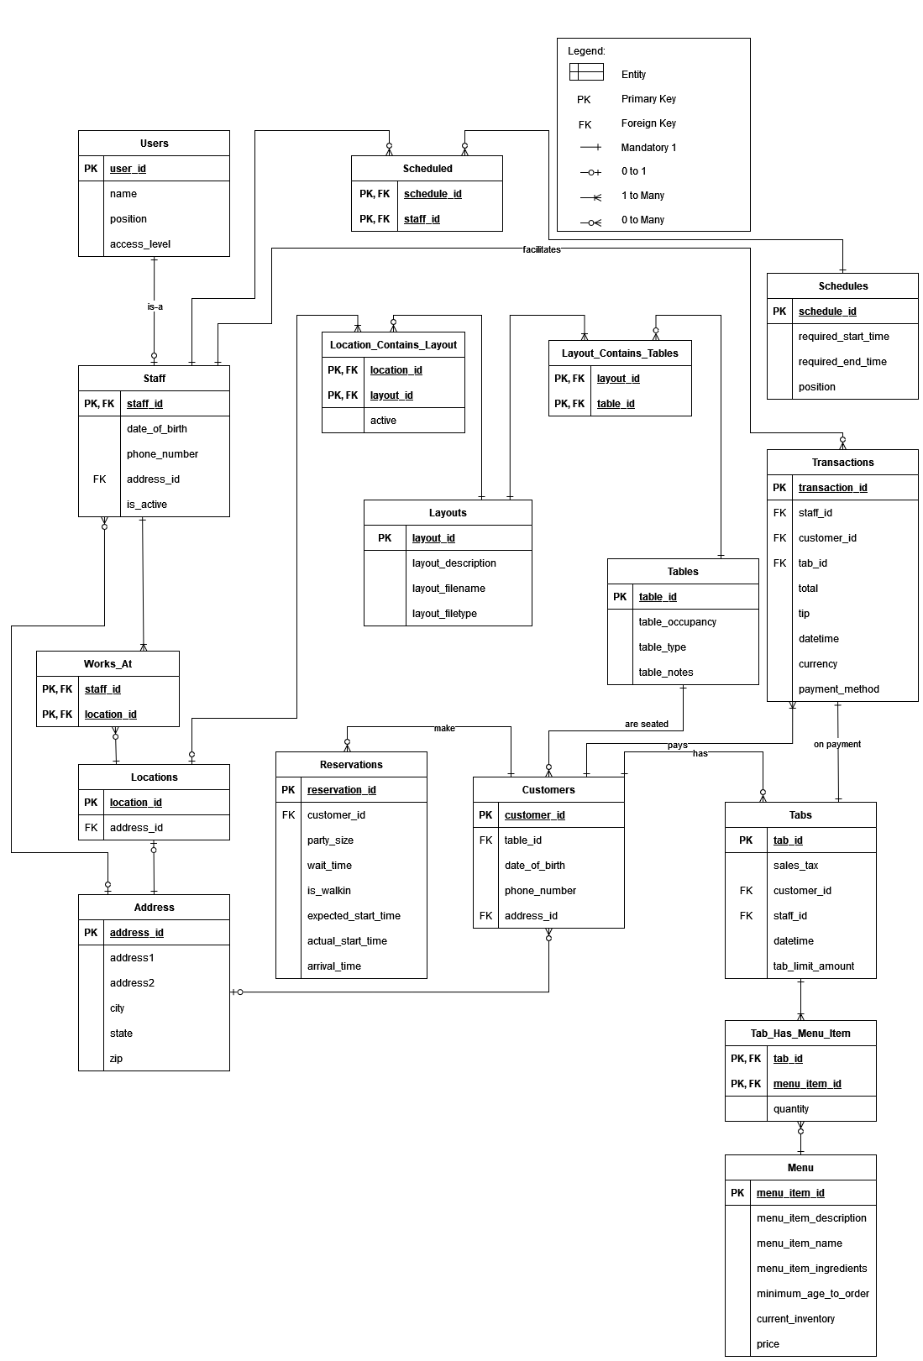

## Assumptions and Constraints

1. Unless otherwise noted, functional dependencies that only return themselves were not written to keep the document concise.
2. Table availability can be computed based on which customers are seated at a given table.
3. Customer age can be calculated on the fly.
4. Tab total can be calculated on the fly.
5. The following tables were extrapolated from the relationship types as defined in the ERD
   1. Address
   2. Works_At
   3. Location_Contains_Layout
   4. Layout_Contains_Tables
   5. Tab_Has_Menu_Item

# 

# Milestone 4: Normalization

|  |  |  |  |  |  |  |
| --- | --- | --- | --- | --- | --- | --- |
|  | ***Name of the table*** | ***Users*** | | | | |
|  | **Description** | A user is a person who has access to the system. This may include staff as a type of user who work in the restaurant, or others like system admins or auditors | | | | |
|  | **Attribute** | **Description** | | **Type** | **Examples of values** | **Notes** |
|  | user_id | Unique identifier | | string | “9A9999” |  |
|  | first_name | First name of user | | string | “John” | Cannot be Null |
|  | last_name | Last name of user | | string | “Doe” | Cannot be Null |
|  | email | Email of user | | string | “john.doe@me.com” |  |
|  | position | Title of user in system | | “Kitchen Manager” | Can be null |  |
|  | access_level | Level of access the user has to the system | | string | “admin” |  |
|  | **Functional Dependencies and Keys** | | | | | |
|  | **Functional dependencies** | user_id → name, position, access_level | | | | |
|  | **Candidate keys** | user_id | | | | |
|  | **Normalization** | | | | | |
|  | **1NF** | **Yes** | Each cell contains an atomic value | | | |
|  | **2NF** | **Yes** | All non-key attributes are determined by the entire PK | | | |
|  | **3NF** | **Yes** | Table is in BCNF | | | |
|  | **BCNF** | **Yes** | There is no transitive dependency between non-key attributes (Attributes are not dependent on anything but user_id) | | | |

|  |  |  |  |  |  |  |
| --- | --- | --- | --- | --- | --- | --- |
|  | ***Name of the table*** | ***Staff*** | | | | |
|  | **Description** | Staff is a user of the system who regularly use system for its intended purpose | | | | |
|  | **Attribute** | **Description** | | **Type** | **Examples of values** | **Notes** |
|  | staff_id | Unique identifier | | string | “9A9999” | FK to User |
|  | date_of_birth | DOB of staff member | | string | “2024-02-29” |  |
|  | phone_number | Phone number of staff member | | string | “555-555-5555” |  |
|  | address_id | FK to Address | | integer | 123456 |  |
|  | is_active | Is the staff member currently an employee | | boolean |  |  |
|  | **Functional Dependencies and Keys** | | | | | |
|  | **Functional dependencies** | staff_id→ date_of_birth, phone_number, address_id, is_active | | | | |
|  | **Candidate keys** | staff_id | | | | |
|  | **Normalization** | | | | | |
|  | **1NF** | **Yes** | Each cell contains an atomic value | | | |
|  | **2NF** | **Yes** | All non-key attributes are determined by the entire PK | | | |
|  | **3NF** | **Yes** | Table is in BCNF | | | |
|  | **BCNF** | **Yes** | There is no transitive dependency between non-key attributes (Attributes are not dependent on anything but staff_id) | | | |

|  |  |  |  |  |  |  |
| --- | --- | --- | --- | --- | --- | --- |
|  | ***Name of the table*** | ***Works_At*** | | | | |
|  | **Description** | Maintains the location of which an employee is employed at | | | | |
|  | **Attribute** | **Description** | | **Type** | **Examples of values** | **Notes** |
|  | staff_id | FK to User | | string | “9A9999” |  |
|  | location_id | FK to Locations | | integer | 123456 |  |
|  | **Functional Dependencies and Keys** | | | | | |
|  | **Functional dependencies** | none | | | | |
|  | **Candidate keys** | staff_id, location_id | | | | |
|  | **Normalization** | | | | | |
|  | **1NF** | **Yes** | Each cell contains an atomic value | | | |
|  | **2NF** | **Yes** | All non-key attributes are determined by the entire PK (There are no non-key attributes) | | | |
|  | **3NF** | **Yes** | Table is in BCNF | | | |
|  | **BCNF** | **Yes** | There is no transitive dependency between non-key attributes (There are no non-key attributes) | | | |

|  |  |  |  |  |  |  |
| --- | --- | --- | --- | --- | --- | --- |
|  | ***Name of the table*** | ***Locations*** | | | | |
|  | **Description** | Maintains the location of active stores | | | | |
|  | **Attribute** | **Description** | | **Type** | **Examples of values** | **Notes** |
|  | location_id | Unique identifier | | integer | 123456 |  |
|  | address_id | FK to Locations | | integer | 123456 |  |
|  | **Functional Dependencies and Keys** | | | | | |
|  | **Functional dependencies** | none | | | | |
|  | **Candidate keys** | location_id, address_id | | | | |
|  | **Normalization** | | | | | |
|  | **1NF** | **Yes** | Each cell contains an atomic value | | | |
|  | **2NF** | **Yes** | All non-key attributes are determined by the entire PK (There are no non-key attributes) | | | |
|  | **3NF** | **Yes** | Table is in BCNF | | | |
|  | **BCNF** | **Yes** | There is no transitive dependency between non-key attributes (There are no non-key attributes) | | | |

|  |  |  |  |  |  |  |
| --- | --- | --- | --- | --- | --- | --- |
|  | ***Name of the table*** | ***Address*** | | | | |
|  | **Description** | Maintains a lookup of addresses | | | | |
|  | **Attribute** | **Description** | | **Type** | **Examples of values** | **Notes** |
|  | address_id | Unique identifier | | integer | 123456 |  |
|  | address1 | First address line | | string | 42 Wallaby Way |  |
|  | address2 | Second address line | | string | APT 1 |  |
|  | city | City name | | string | Boston |  |
|  | state | State abbreviation | | string | MA |  |
|  | zip | Zip code digits | | string | “123456” | Uses string because some internal code use letters |
|  | **Functional Dependencies and Keys** | | | | | |
|  | **Functional dependencies** | address_id→ address1, address2, city, state, zip  zip → city, state | | | | |
|  | **Candidate keys** | address_id, zip | | | | |
|  | **Normalization** | | | | | |
|  | **1NF** | **Yes** | Each cell contains an atomic value | | | |
|  | **2NF** | **No** | The city and state attributes can be derived from zip, which is not a PK | | | |
|  | **3NF** | **No** | Not in BCNF | | | |
|  | **BCNF** | **No** | Not in 2NF | | | |

|  |  |  |  |  |  |  |
| --- | --- | --- | --- | --- | --- | --- |
|  | ***Name of the table*** | ***Scheduled*** | | | | |
|  | **Description** | Links the staff to a schedule | | | | |
|  | **Attribute** | **Description** | | **Type** | **Examples of values** | **Notes** |
|  | schedule_id | FK to Schedules | | integer | 123456 |  |
|  | staff_id | FK to Staff | | integer | 123456 |  |
|  | **Functional Dependencies and Keys** | | | | | |
|  | **Functional dependencies** | none | | | | |
|  | **Candidate keys** | schedule_id, staff_id | | | | |
|  | **Normalization** | | | | | |
|  | **1NF** | **Yes** | Each cell contains an atomic value | | | |
|  | **2NF** | **Yes** | All non-key attributes are determined by the entire PK (There are no non-key attributes) | | | |
|  | **3NF** | **Yes** | Table is in BCNF | | | |
|  | **BCNF** | **Yes** | There is no transitive dependency between non-key attributes (There are no non-key attributes) | | | |

|  |  |  |  |  |  |  |
| --- | --- | --- | --- | --- | --- | --- |
|  | ***Name of the table*** | ***Schedules*** | | | | |
|  | **Description** | Maintains a collection of schedule positions to be filled | | | | |
|  | **Attribute** | **Description** | | **Type** | **Examples of values** | **Notes** |
|  | schedule_id | Unique identifier | | integer | 123456 |  |
|  | required_start_time | Day and time of shift start | | string | '2024-02-27T20:03:56.002Z' |  |
|  | required_end_time | Day and time of shift end | | string | '2024-02-27T20:04:56.002Z' |  |
|  | position | Position to be filled | | string | ‘host’ |  |
|  | **Functional Dependencies and Keys** | | | | | |
|  | **Functional dependencies** | schedule_id → required_start_time, required_end_time, position | | | | |
|  | **Candidate keys** | schedule_id | | | | |
|  | **Normalization** | | | | | |
|  | **1NF** | **Yes** | Each cell contains an atomic value | | | |
|  | **2NF** | **Yes** | All non-key attributes are determined by the entire PK | | | |
|  | **3NF** | **Yes** | Table is in BCNF | | | |
|  | **BCNF** | **Yes** | There is no transitive dependency between non-key attributes (Attributes are not dependent on anything but schedule_id) | | | |

|  |  |  |  |  |  |  |
| --- | --- | --- | --- | --- | --- | --- |
|  | ***Name of the table*** | ***Location_Contains_Layout*** | | | | |
|  | **Description** | Maintains the relationship between a Location and its Layouts. | | | | |
|  | **Attribute** | **Description** | | **Type** | **Examples of values** | **Notes** |
|  | location_id | FK to Locations | | integer | 123456 |  |
|  | layout_id | FK to Layouts | | integer | 123456 |  |
|  | active | Notes if the layout is currently active | | boolean | true |  |
|  | **Functional Dependencies and Keys** | | | | | |
|  | **Functional dependencies** | location_id, layout_id → active | | | | |
|  | **Candidate keys** | location_id, layout_id | | | | |
|  | **Normalization** | | | | | |
|  | **1NF** | **Yes** | Each cell contains an atomic value | | | |
|  | **2NF** | **Yes** | All non-key attributes are determined by the entire PK | | | |
|  | **3NF** | **Yes** | Table is in BCNF | | | |
|  | **BCNF** | **Yes** | There is no transitive dependency between non-key attributes (Attributes are not dependent on anything but [location_id, layout_id]) | | | |

|  |  |  |  |  |  |  |
| --- | --- | --- | --- | --- | --- | --- |
|  | ***Name of the table*** | ***Layout_Contains_Tables*** | | | | |
|  | **Description** | Maintains the relationship between a Layout and its Tables. | | | | |
|  | **Attribute** | **Description** | | **Type** | **Examples of values** | **Notes** |
|  | table_id | FK to Tables | | integer | 123456 |  |
|  | layout_id | FK to Layouts | | integer | 123456 |  |
|  | **Functional Dependencies and Keys** | | | | | |
|  | **Functional dependencies** | none | | | | |
|  | **Candidate keys** | table_id, layout_id | | | | |
|  | **Normalization** | | | | | |
|  | **1NF** | **Yes** | Each cell contains an atomic value | | | |
|  | **2NF** | **Yes** | All non-key attributes are determined by the entire PK (There are no non-key attributes) | | | |
|  | **3NF** | **Yes** | Table is in BCNF | | | |
|  | **BCNF** | **Yes** | There is no transitive dependency between non-key attributes (No non-key attributes) | | | |

|  |  |  |  |  |  |  |
| --- | --- | --- | --- | --- | --- | --- |
|  | ***Name of the table*** | ***Layouts*** | | | | |
|  | **Description** | Maintains a collection of Layout information | | | | |
|  | **Attribute** | **Description** | | **Type** | **Examples of values** | **Notes** |
|  | layout_id | Unique identifier | | integer | 123456 |  |
|  | layout_description | Descriptor of the layout | | string | 'Booth and High Table setup' |  |
|  | layout_filename | Name of the layout design file | | string | ‘six_booth_8_high_table’ |  |
|  | layout_filetype | File extension of the file | | string | ‘.xml’ |  |
|  | **Functional Dependencies and Keys** | | | | | |
|  | **Functional dependencies** | layout_id → layout_description, layout_filename, layout_filetype | | | | |
|  | **Candidate keys** | layout_id | | | | |
|  | **Normalization** | | | | | |
|  | **1NF** | **Yes** | Each cell contains an atomic value | | | |
|  | **2NF** | **Yes** | All non-key attributes are determined by the entire PK | | | |
|  | **3NF** | **Yes** | Table is in BCNF | | | |
|  | **BCNF** | **Yes** | There is no transitive dependency between non-key attributes (Attributes are not dependent on anything but layout_id) | | | |

|  |  |  |  |  |  |  |
| --- | --- | --- | --- | --- | --- | --- |
|  | ***Name of the table*** | ***Tables*** | | | | |
|  | **Description** | Maintains a collection of the different types of Tables | | | | |
|  | **Attribute** | **Description** | | **Type** | **Examples of values** | **Notes** |
|  | table_id | Unique identifier | | integer | 123456 |  |
|  | table_occupancy | Number of seats at the table | | integer | 6 |  |
|  | table_type | Type of Table | | string | ‘Booth’ |  |
|  | table_notes | Additional information on the table | | string | ‘Broken table leg' |  |
|  | **Functional Dependencies and Keys** | | | | | |
|  | **Functional dependencies** | table_id → table_occupancy, table_type, table_notes | | | | |
|  | **Candidate keys** | table_id | | | | |
|  | **Normalization** | | | | | |
|  | **1NF** | **Yes** | Each cell contains an atomic value | | | |
|  | **2NF** | **Yes** | All non-key attributes are determined by the entire PK | | | |
|  | **3NF** | **Yes** | Table is in BCNF | | | |
|  | **BCNF** | **Yes** | There is no transitive dependency between non-key attributes (Attributes are not dependent on anything but table_id) | | | |

|  |  |  |  |  |  |  |
| --- | --- | --- | --- | --- | --- | --- |
|  | ***Name of the table*** | ***Customers*** | | | | |
|  | **Description** | Maintains a collection of the customer information | | | | |
|  | **Attribute** | **Description** | | **Type** | **Examples of values** | **Notes** |
|  | customer_id | Unique identifier | | integer | 123456 |  |
|  | table_id | Table the customer is sitting at | | integer | 123456 | FK to Tables |
|  | date_of_birth | DOB of customer | | string | ‘2024-02-27’ |  |
|  | phone_number | Customer phone number | | string | ‘555-555-5555' |  |
|  | address_id | Address of customer | | integer | 123456 | FK to Addresses |
|  | **Functional Dependencies and Keys** | | | | | |
|  | **Functional dependencies** | customer_id → table_id, date_of_birth, phone_number, address_id | | | | |
|  | **Candidate keys** | customer_id | | | | |
|  | **Normalization** | | | | | |
|  | **1NF** | **Yes** | Each cell contains an atomic value | | | |
|  | **2NF** | **Yes** | All non-key attributes are determined by the entire PK | | | |
|  | **3NF** | **Yes** | Table is in BCNF | | | |
|  | **BCNF** | **Yes** | There is no transitive dependency between non-key attributes (Attributes are not dependent on anything but customer_id) | | | |

|  |  |  |  |  |  |  |
| --- | --- | --- | --- | --- | --- | --- |
|  | ***Name of the table*** | ***Reservations*** | | | | |
|  | **Description** | Maintains a collection of customer reservations (as well as walk-ins, basically a reservation that starts immediately) | | | | |
|  | **Attribute** | **Description** | | **Type** | **Examples of values** | **Notes** |
|  | reservation_id | Unique identifier | | integer | 123456 |  |
|  | customer_id | FK to Customers | | integer | 123456 |  |
|  | party_size | Number of people in party | | integer | 5 |  |
|  | wait_time | Expected wait time for customer party (in minutes) | | integer | 45 |  |
|  | is_walkin | Is this a future reservation | | boolean | false |  |
|  | expected_start_time | Time reservation should start | | string | '2024-02-27T20:04:56.002Z’ |  |
|  | actual_start_time | Time reservation actually starts | | string | '2024-02-27T20:04:56.002Z' |  |
|  | arrival_time | Time customer shows up | | string | '2024-02-27T20:04:56.002Z' |  |
|  | **Functional Dependencies and Keys** | | | | | |
|  | **Functional dependencies** | reservation_id → customer_id, party_size, wait_time, is_walkin, expected_start_time, actual_start_time, arrival_time | | | | |
|  | **Candidate keys** | reservation_id | | | | |
|  | **Normalization** | | | | | |
|  | **1NF** | **Yes** | Each cell contains an atomic value | | | |
|  | **2NF** | **Yes** | All non-key attributes are determined by the entire PK | | | |
|  | **3NF** | **Yes** | Table is in BCNF | | | |
|  | **BCNF** | **Yes** | There is no transitive dependency between non-key attributes (Attributes are not dependent on anything but reservation_id) | | | |

|  |  |  |  |  |  |  |
| --- | --- | --- | --- | --- | --- | --- |
|  | ***Name of the table*** | ***Transactions*** | | | | |
|  | **Description** | Maintains a collection of transactional information | | | | |
|  | **Attribute** | **Description** | | **Type** | **Examples of values** | **Notes** |
|  | transaction_id | Unique identifier | | integer | 123456 |  |
|  | staff_id | Staff member who processed the transaction | | integer | 123456 | FK to Staff |
|  | customer_id | Customer to whom the transaction belongs too | | integer | 123456 | FK to Customers |
|  | tab_id | Tab of which the transaction is paying for | | integer | 123456 | FK to Tabs |
|  | total | Amount the transaction covers | | float | 1.45 |  |
|  | tip | Additional amount for tip | | float | 1.45 |  |
|  | datetime | Date and time transaction was processed | | string | '2024-02-27T20:04:56.002Z' |  |
|  | currency | Currency code of payment | | string | ‘USD’ |  |
|  | payment_method | Payment method | | string | ‘Cash’ |  |
|  | **Functional Dependencies and Keys** | | | | | |
|  | **Functional dependencies** | transaction_id → staff_id, customer_id, tab_id, total, tip, datetime, currency, datetime, payment_method | | | | |
|  | **Candidate keys** | transaction_id | | | | |
|  | **Normalization** | | | | | |
|  | **1NF** | **Yes** | Each cell contains an atomic value | | | |
|  | **2NF** | **Yes** | All non-key attributes are determined by the entire PK | | | |
|  | **3NF** | **Yes** | Table is in BCNF | | | |
|  | **BCNF** | **Yes** | There is no transitive dependency between non-key attributes (Attributes are not dependent on anything but transaction_id) | | | |

|  |  |  |  |  |  |  |
| --- | --- | --- | --- | --- | --- | --- |
|  | ***Name of the table*** | ***Tabs*** | | | | |
|  | **Description** | Maintains a collection information related to customer tab information | | | | |
|  | **Attribute** | **Description** | | **Type** | **Examples of values** | **Notes** |
|  | tab_id | Unique Identifier | | integer | 123456 |  |
|  | sales_tax | Sales tax applied to tab | | float | 2.65 |  |
|  | customer_id | Customer who owns tab | | integer | 123456 | FK to Customers |
|  | staff_id | Staff who manages tab | | integer | 123456 | FK to Staff |
|  | datetime | Day and time when tab was started | | string | '2024-02-27T20:04:56.002Z' |  |
|  | tab_limit_amount | Dollar amount of when to notify customer of tab value | | float | 2.65 |  |
|  | **Functional Dependencies and Keys** | | | | | |
|  | **Functional dependencies** | tab_id → sales_tax, customer_id, staff_id, datetime, tab_limit_amount | | | | |
|  | **Candidate keys** | tab_id | | | | |
|  | **Normalization** | | | | | |
|  | **1NF** | **Yes** | Each cell contains an atomic value | | | |
|  | **2NF** | **Yes** | All non-key attributes are determined by the entire PK | | | |
|  | **3NF** | **Yes** | Table is in BCNF | | | |
|  | **BCNF** | **Yes** | There is no transitive dependency between non-key attributes (Attributes are not dependent on anything but tab_id) | | | |

|  |  |  |  |  |  |  |
| --- | --- | --- | --- | --- | --- | --- |
|  | ***Name of the table*** | ***Tab_Has_Menu_Item*** | | | | |
|  | **Description** | Maintains the relationship between a Tab and the menu items on the tab | | | | |
|  | **Attribute** | **Description** | | **Type** | **Examples of values** | **Notes** |
|  | tab_id | FK to Tabs | | integer | 123456 |  |
|  | menu_item_id | FK to Menu | | integer | 123456 |  |
|  | quantity | Notes amount of menu item purhcased | | integer | 2 |  |
|  | **Functional Dependencies and Keys** | | | | | |
|  | **Functional dependencies** | tab_id, menu_item_id → quantity | | | | |
|  | **Candidate keys** | tab_id, menu_item_id | | | | |
|  | **Normalization** | | | | | |
|  | **1NF** | **Yes** | Each cell contains an atomic value | | | |
|  | **2NF** | **Yes** | All non-key attributes are determined by the entire PK | | | |
|  | **3NF** | **Yes** | Table is in BCNF | | | |
|  | **BCNF** | **Yes** | There is no transitive dependency between non-key attributes (Attributes are not dependent on anything but [tab_id, menu_item_id]) | | | |

|  |  |  |  |  |  |  |
| --- | --- | --- | --- | --- | --- | --- |
|  | ***Name of the table*** | ***Menu*** | | | | |
|  | **Description** | Maintains a collection information of related to the items on the menu | | | | |
|  | **Attribute** | **Description** | | **Type** | **Examples of values** | **Notes** |
|  | menu_item_id | Unique Identifier | | integer | 123456 |  |
|  | menu_item_description | Human readable item description | | string | ‘Cheeseburger’ |  |
|  | menu_item_ingredients | All ingredient in item, separated by a comma | | string | ‘gluten, ground beef, butter’ |  |
|  | minimum_age_to_order | Age restriction on ordering | | integer | 21 |  |
|  | current_inventory | Amount of item remaining | | integer | 120 |  |
|  | price | Cost of menu item | | float | 1.66 |  |
|  | **Functional Dependencies and Keys** | | | | | |
|  | **Functional dependencies** | menu_item_id → menu_item_description, menu_item_ingredients, minimum_age_to_order, current_inventory, price | | | | |
|  | **Candidate keys** | menu_item_id | | | | |
|  | **Normalization** | | | | | |
|  | **1NF** | **Yes** | Each cell contains an atomic value | | | |
|  | **2NF** | **Yes** | All non-key attributes are determined by the entire PK | | | |
|  | **3NF** | **Yes** | Table is in BCNF | | | |
|  | **BCNF** | **Yes** | There is no transitive dependency between non-key attributes (Attributes are not dependent on anything but menu_item_id) | | | |

# Milestone 5: Physical Design

## Assumptions and Constraints

## The attribute “name” in the USERS table was implemented as first_name and last_name since the full name can be computed.

All ids must be positive so that they are more meaningful as identification.

The tables in the database will be created with the same relationships as depicted in the Logical Model shown earlier in the document. Any changes to relationships will be noted.

## Naming Conventions

The tables were created under the Schema provided in the docker image. The table names use underscores (“_”) to denote different words, or snake case as it is commonly referred as.

## Tables

|  |  |
| --- | --- |
| Physical Design | USERS |
| Primary Key | user_id |
| Foreign Keys | - |
| SQL Code | CREATE TABLE users (  user_id INTEGER CONSTRAINT user_id CHECK (user_id > 0),  first_name VARCHAR2(30) NOT NULL,  last_name VARCHAR2(30) NOT NULL,  position VARCHAR(30) NOT NULL,  access_level VARCHAR(15),  email VARCHAR(30),  CONSTRAINT user_email UNIQUE (email),  PRIMARY KEY (user_id)  ) |
| Count of records in the table | 20 |

|  |  |
| --- | --- |
| Physical Design | STAFF |
| Primary Key | staff_id |
| Foreign Keys | staff_id --> USERS.user_id  address_id --> ADDRESS.address_id |
| SQL Code | CREATE TABLE staff (  staff_id INTEGER CONSTRAINT staff_id CHECK (staff_id > 0),  date_of_birth VARCHAR(10) NOT NULL CONSTRAINT s_dob CHECK (length(date_of_birth) = 10),  phone_number VARCHAR(12) CONSTRAINT s_pn CHECK (length(phone_number) = 12),  position VARCHAR(30) NOT NULL,  address_id INTEGER,  is_active INTEGER,  PRIMARY KEY (staff_id),  FOREIGN KEY (staff_id) REFERENCES users(user_id),  FOREIGN KEY (address_id) REFERENCES address(address_id)  ) |
| Count of records in the table | 20 |

|  |  |
| --- | --- |
| Physical Design | SCHEDULES |
| Primary Key | schedule_id |
| Foreign Keys |  |
| SQL Code | CREATE TABLE schedules (  schedule_id INTEGER CONSTRAINT schedule_id CHECK (schedule_id > 0),  required_start_time VARCHAR(24) NOT NULL CONSTRAINT s_start_time CHECK (length(required_start_time) = 24),  required_end_time VARCHAR(24) NOT NULL CONSTRAINT s_end_time CHECK (length(required_end_time) = 24),  position VARCHAR(30) NOT NULL,  PRIMARY KEY (schedule_id)  ) |
| Count of records in the table | 20 |

|  |  |
| --- | --- |
| Physical Design | SCHEDULED |
| Primary Key | schedule_id, staff_id |
| Foreign Keys | schedule_id --> SCHEDULES.schedule_id  staff_id --> STAFF.staff_id |
| SQL Code | CREATE TABLE scheduled (  schedule_id INTEGER CONSTRAINT scheduled_id CHECK (schedule_id > 0),  staff_id INTEGER CONSTRAINT scheduled_staff_id CHECK (staff_id > 0),  PRIMARY KEY (schedule_id, staff_id),  FOREIGN KEY(schedule_id) REFERENCES schedules(schedule_id),  FOREIGN KEY(staff_id) REFERENCES staff(staff_id)  ) |
| Count of records in the table | 20 |

|  |  |
| --- | --- |
| Physical Design | ADDRESS |
| Primary Key | address_id |
| Foreign Keys |  |
| SQL Code | CREATE TABLE address (  address_id INTEGER CONSTRAINT address_id CHECK (address_id > 0),  address1 VARCHAR(30),  address2 VARCHAR(30),  city VARCHAR(30),  state VARCHAR(30),  zip VARCHAR(15),  PRIMARY KEY (address_id)  ) |
| Count of records in the table | 20 |

|  |  |
| --- | --- |
| Physical Design | LOCATIONS |
| Primary Key | location_id |
| Foreign Keys | Address_id --> ADDRESS.address_id |
| SQL Code | CREATE TABLE locations (  location_id INTEGER CONSTRAINT location_id CHECK (location_id > 0),  address_id INTEGER CONSTRAINT locations_address_id CHECK (address_id > 0),  PRIMARY KEY (location_id),  FOREIGN KEY (address_id) REFERENCES address(address_id)  ) |
| Count of records in the table | 20 |

|  |  |
| --- | --- |
| Physical Design | LAYOUTS |
| Primary Key | layout_id |
| Foreign Keys |  |
| SQL Code | CREATE TABLE layouts (  layout_id INTEGER CONSTRAINT l_layout_id CHECK (layout_id > 0),  layout_description VARCHAR(50),  layout_filename VARCHAR(30),  layout_filetype VARCHAR(10),  PRIMARY KEY (layout_id)  ) |
| Count of records in the table | 20 |

|  |  |
| --- | --- |
| Physical Design | WORKS_AT |
| Primary Key | staff_id, location_id |
| Foreign Keys | staff_id --> STAFF.staff_id  location_id --> LOCATIONS.location_id |
| SQL Code | CREATE TABLE layouts (  layout_id INTEGER CONSTRAINT l_layout_id CHECK (layout_id > 0),  layout_description VARCHAR(50),  layout_filename VARCHAR(30),  layout_filetype VARCHAR(10),  PRIMARY KEY (layout_id)  ) |
| Count of records in the table | 20 |

|  |  |
| --- | --- |
| Physical Design | LOCATIONS_CONTAINS_LAYOUTS |
| Primary Key | layout_id, location_id |
| Foreign Keys | layout_id --> LAYOUTS.layout_id  location_id --> LOCATIONS.location_id |
| SQL Code | CREATE TABLE locations_contains_layouts (  location_id INTEGER CONSTRAINT lcl_location_id CHECK (location_id > 0),  layout_id INTEGER CONSTRAINT lcl_layout_id CHECK (layout_id > 0),  active INTEGER,  PRIMARY KEY (location_id, layout_id),  FOREIGN KEY (layout_id) REFERENCES layouts(layout_id),  FOREIGN KEY (location_id) REFERENCES locations(location_id)  ) |
| Count of records in the table | 20 |

|  |  |
| --- | --- |
| Physical Design | TABLES |
| Primary Key | table_id |
| Foreign Keys |  |
| SQL Code | CREATE TABLE tables (  table_id INTEGER CONSTRAINT t_table_id CHECK (table_id > 0),  table_occupancy INTEGER,  table_type STRING,  table_notes VARCHAR(50),  PRIMARY KEY (table_id)  ) |
| Count of records in the table | 20 |

|  |  |
| --- | --- |
| Physical Design | LAYOUT_CONTAINS_TABLES |
| Primary Key | table_id, layout_id |
| Foreign Keys | table_id --> TABLES.table_id  layout_id --> LAYOUTS.layout_id |
| SQL Code | CREATE TABLE layout_contains_tables (  table_id INTEGER CONSTRAINT lct_table_id CHECK (table_id > 0),  layout_id INTEGER CONSTRAINT lct_layout_id CHECK (layout_id > 0),  PRIMARY KEY (table_id, layout_id),  FOREIGN KEY (table_id) REFERENCES tables(table_id),  FOREIGN KEY (layout_id) REFERENCES layouts(layout_id) |
| Count of records in the table | 20 |

|  |  |
| --- | --- |
| Physical Design | CUSTOMERS |
| Primary Key | customer_id, |
| Foreign Keys | table_id --> TABLES.table_id  address_id --> ADDRESS.layout_id |
| SQL Code | CREATE TABLE customers (  customer_id INTEGER CONSTRAINT c_customer_id CHECK (customer_id > 0),  table_id INTEGER CONSTRAINT c_table_id CHECK (table_id > 0),  address_id INTEGER CONSTRAINT c_address_id CHECK (address_id > 0),  date_of_birth VARCHAR(10) NOT NULL CONSTRAINT c_dob CHECK (length(date_of_birth) = 10),  phone_number VARCHAR(12) CONSTRAINT c_pn CHECK (length(phone_number) = 12),  PRIMARY KEY (customer_id),  FOREIGN KEY (table_id) REFERENCES tables(table_id),  FOREIGN KEY (address_id) REFERENCES address(address_id)  ) |
| Count of records in the table | 20 |

|  |  |
| --- | --- |
| Physical Design | RESERVATIONS |
| Primary Key | reservation_id, |
| Foreign Keys | customer_id --> CUSTOMERS.customer_id |
| SQL Code | CREATE TABLE reservations (  reservation_id INTEGER CONSTRAINT r_reservation_id CHECK (reservation_id > 0),  customer_id INTEGER CONSTRAINT r_customer_id CHECK (customer_id > 0),  party_size INTEGER,  wait_time INTEGER,  is_walkin INTEGER,  expected_start_time VARCHAR(24) NOT NULL CONSTRAINT r_expected_start_time CHECK (length(expected_start_time) = 24),  actual_start_time VARCHAR(24) NOT NULL CONSTRAINT r_actual_start_time CHECK (length(actual_start_time) = 24),  arrival_time VARCHAR(24) NOT NULL CONSTRAINT r_arrival_time CHECK (length(arrival_time) = 24),  PRIMARY KEY (reservation_id),  FOREIGN KEY (customer_id) REFERENCES customers(customer_id)  ) |
| Count of records in the table | 20 |

|  |  |
| --- | --- |
| Physical Design | TABS |
| Primary Key | tab_id, |
| Foreign Keys | customer_id --> CUSTOMERS.customer_id  staff_id --> STAFF.staff_id |
| SQL Code | CREATE TABLE tabs (  tab_id INTEGER CONSTRAINT t_tab_id CHECK (tab_id > 0),  sales_tax FLOAT,  customer_id INTEGER CONSTRAINT t_customer_id CHECK (customer_id > 0),  staff_id INTEGER CONSTRAINT t_staff_id CHECK (staff_id > 0),  datetime VARCHAR(24) NOT NULL CONSTRAINT t_datetime CHECK (length(datetime) = 24),  tab_limit_amount FLOAT,  PRIMARY KEY (tab_id),  FOREIGN KEY (customer_id) REFERENCES customers(customer_id) ,  FOREIGN KEY (staff_id) REFERENCES staff(staff_id)  ) |
| Count of records in the table | 20 |

|  |  |
| --- | --- |
| Physical Design | TRANSACTIONS |
| Primary Key | transaction_id, |
| Foreign Keys | staff_id --> STAFF.staff_id  customer_id --> CUSTOMERS.customer_id  tab_id --> TABS.tab_id |
| SQL Code | CREATE TABLE transactions (  transaction_id INTEGER CONSTRAINT tr_transaction_id CHECK (transaction_id > 0),  staff_id INTEGER CONSTRAINT tr_staff_id CHECK (staff_id > 0),  customer_id INTEGER CONSTRAINT tr_customer_id CHECK (customer_id > 0),  tab_id INTEGER CONSTRAINT tr_tab_id CHECK (tab_id > 0),  total FLOAT,  tip FLOAT,  datetime VARCHAR(24) NOT NULL CONSTRAINT tr_datetime CHECK (length(datetime) = 24),  currency VARCHAR(3) NOT NULL CONSTRAINT tr_currency CHECK (length(currency) = 3),  payment_method VARCHAR(15),  PRIMARY KEY (transaction_id),  FOREIGN KEY (customer_id) REFERENCES customers(customer_id) ,  FOREIGN KEY (staff_id) REFERENCES staff(staff_id),  FOREIGN KEY (tab_id) REFERENCES tabs(tab_id)  ) |
| Count of records in the table | 20 |

|  |  |
| --- | --- |
| Physical Design | MENU |
| Primary Key | menu_item_id, |
| Foreign Keys |  |
| SQL Code | CREATE TABLE menu (  menu_item_id INTEGER CONSTRAINT m_menu_item_id CHECK (menu_item_id > 0),  menu_item_description VARCHAR(25),  menu_item_ingredients VARCHAR(100),  minimum_age_to_order INTEGER,  price FLOAT,  PRIMARY KEY (menu_item_id)  ) |
| Count of records in the table | 20 |

|  |  |
| --- | --- |
| Physical Design | TAB_HAD_MENU_ITEMS |
| Primary Key | menu_item_id, tab_id |
| Foreign Keys | menu_item_id --> MENU.menu_item_id  tab_id --> TABS.tab_id |
| SQL Code | CREATE TABLE tab_has_menu_items (  menu_item_id INTEGER CONSTRAINT thmi_menu_item_id CHECK (menu_item_id > 0),  tab_id INTEGER CONSTRAINT thmi_tab_id CHECK (tab_id > 0),  quantity INTEGER,  PRIMARY KEY (menu_item_id),  FOREIGN KEY (tab_id) REFERENCES tabs(tab_id),  FOREIGN KEY (menu_item_id) REFERENCES menu(menu_item_id)  ) |
| Count of records in the table | 20 |

**SYSTEM GENERATED ERD**

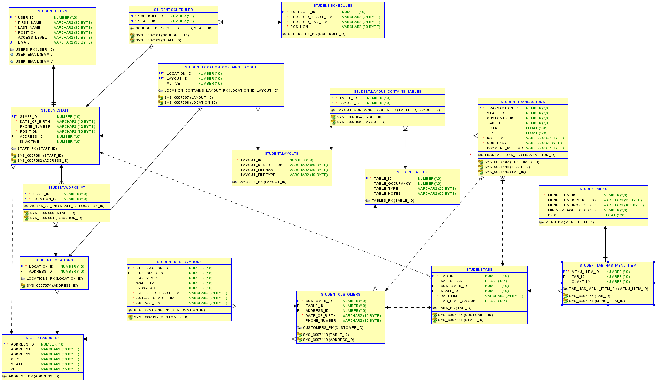

# Milestone 6: SQL queries and

**Note**: Please make sure you add/have 25 records in each table, on average.

|  |  |
| --- | --- |
| **Query 1** |  |
| **English version** |  |
| **Source for the query need in the SRS document** |  |
| **SQL sentence** |  |
| **Example of returned rows (cropped screen caption)** |  |

…